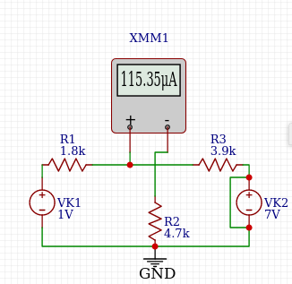
Table 1 – I_{R2} (1V)

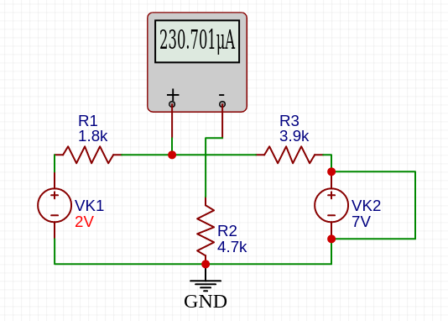
Table 1 – I_{R2} (2V)

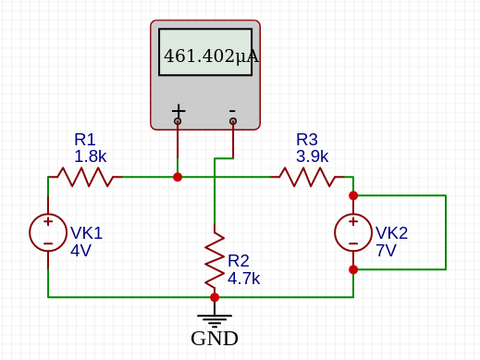
Table 1 – I_{R2} (4V)

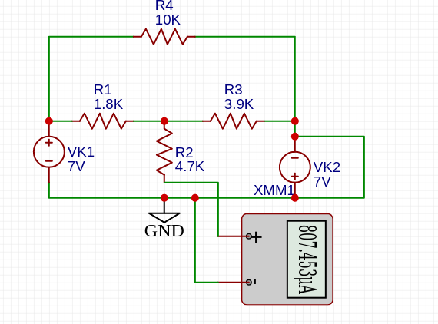Table 2 - 1

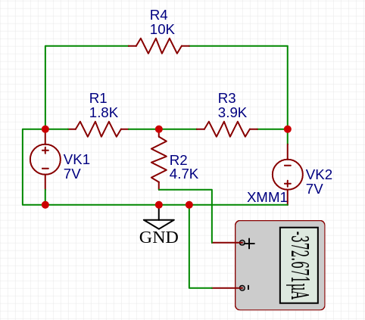
Table 2 - 2

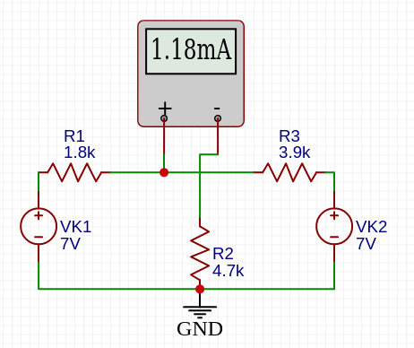
Table 2 - 3
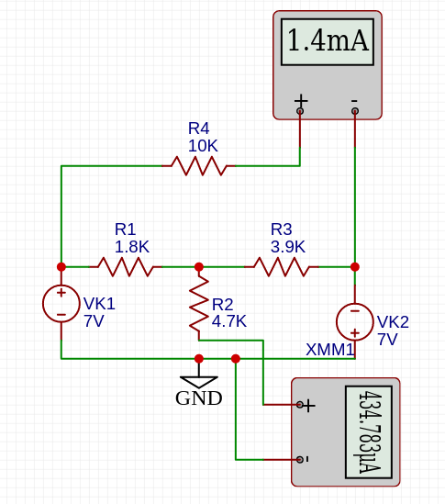
Table 3 - 5

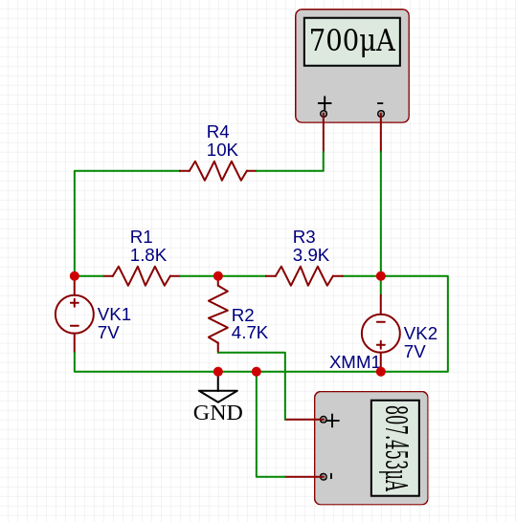
Table 3 - 2

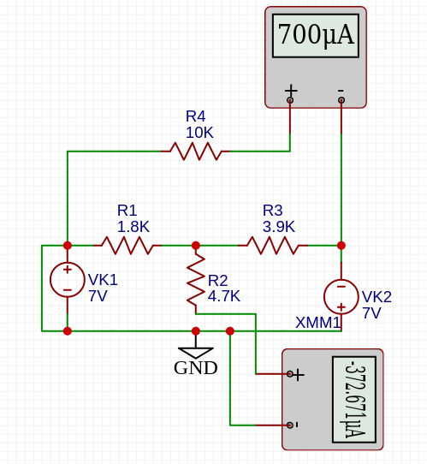
Table 3 - 1

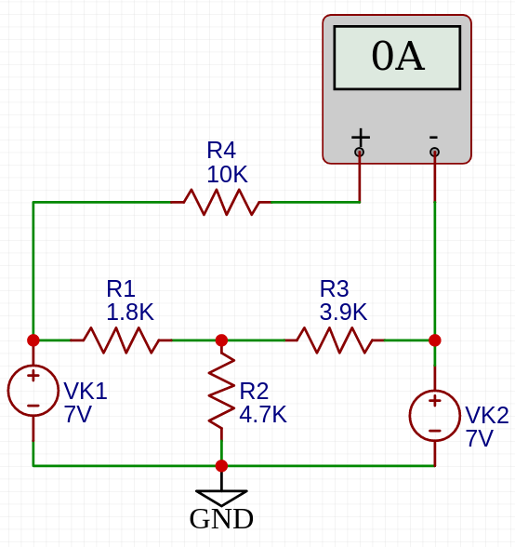
Table 4 - 3
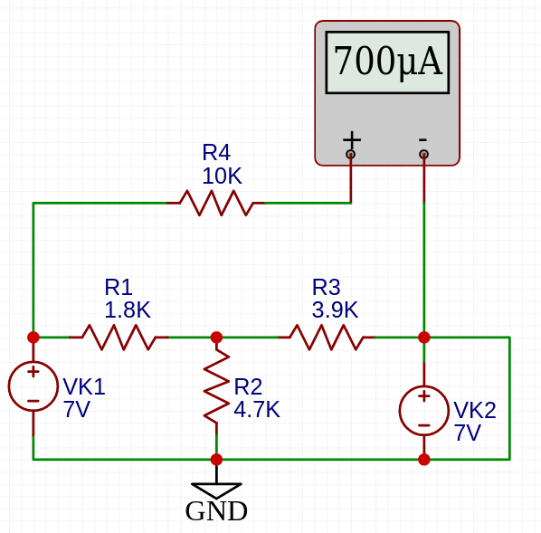
Table 4 - 1
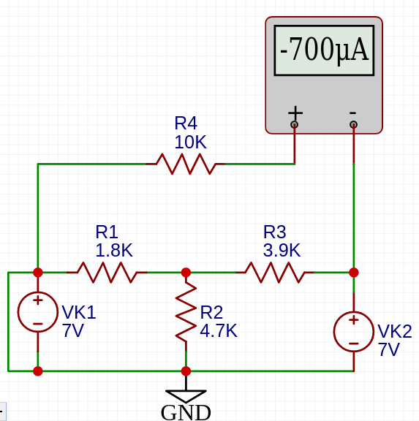
Table 4 - 2

Figure 1: Circuit 1
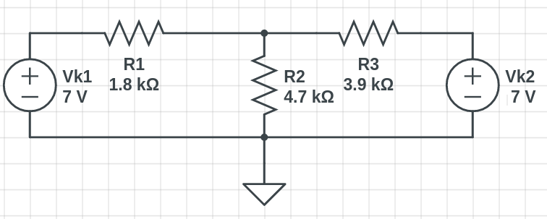

Multiplicativity Theorem
V_{K1}[V ]  Source Volt- age | I_{R2}[mA]  Calculated | I_{R2}[mA]  Measured | Relative  Error [%]
1 | 0.115 mA
2 | 0.23 mA
4 | 0.461 mA
Table 1

Figure 2: Circuit 2
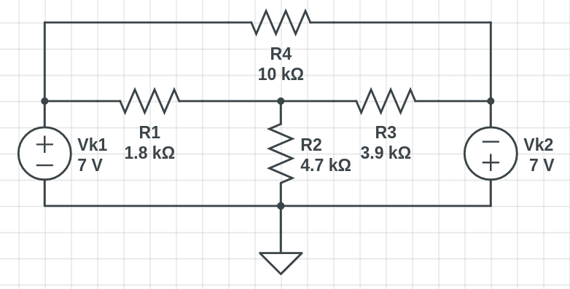

Superposition Theorem
V_{K1}[V ]  Source age | Volt- | V_{K2}[V ]  Source Volt- age | I_{R2}[mA]  Calculated |  | I_{R2}[mA]  Measured |  | Relative  Error [%]
7 |  | 0 | I’  R2 | = 0.807 | I’  R2 | =
0 |  | -7 | I”  R2 | = -0.373 | I”  R2 | =
I’_{R2} + I’’_{R2} = 0.434 mA
7 |  | -7 | I_{R2} = 0.434 |  | I_{R2} =
Table 2

Figure 3: Circuit 3
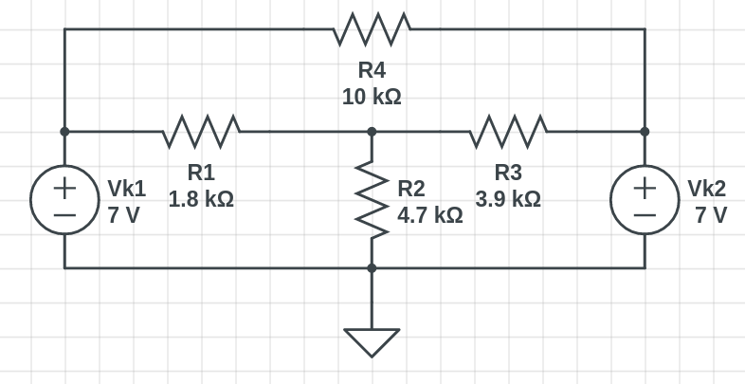

V_{K1}[V ]  Source age | Volt- | V_{K2}[V ]  Source Volt- age | I_{R2}[mA]  Measured |  | I_{R4}[mA]  Measured |  | Relative  Error [%]
7 |  | 0 | I’  R2 | = -0.373 | I’  R4 | =0.7
0 |  | -7 | I”  R2 | = 0.807 | I”  R4 | =0.7
I_{R2}’ + I_{R2}’’ = 0.434 mA
I_{R4}’ + I_{R4}’’ = 1.4 mA
7 |  | -7 | I_{R2} = 0.434 |  | I_{R4} = 1.4
Table 3

V_{K1}[V ]  Source Volt- age | V_{K2}[V ]  Source Volt- age | I_{R4}[mA]  Calculated | I_{R4}[mA]  Measured | Relative  Error [%]
7 | 0 | I’ = 0.7  R4 | I’ =  R4
0 | 7 | I’’ = -0.7  R4 | I’’ =  R4
7 | 7 | I_{R4} = 0 | I_{R4} =
Table 4

